**COMET BAY COLLEGE**

**Physics - Unit 2 - Task 8**

**Research Topic**

**Name: Total Marks /100**

Students: This lists the requirements and some hints for completing research on a desired topic for Senior Physics. However, if you require further assistance, then please contact me immediately. Standard CBC assessment guidelines apply and will be adhered to.

**Assessment accounts for _______ of course**

**Due dates:**

* **Report due __________________**

**Information:**

You are to write a **scientific report** on one of the following **Physicist**.

* Paul Dirac (1902 - 1984: British)
* Nikola Tesla (1857 – 1943: Serbian-born American)
* Albert Einstein (1879 – 1955: German-born American)
* Galileo Galilei (1564 – 1642: Italian)
* Christiaan Huygens (1629 - 1695: Dutch)
* Sir Isaac Newton (1643 - 1727: English)
* Henry Cavendish (1731 - 1810: British)
* Charles Augustin de Coulomb (1736 – 1806: French)
* Hans Christian Oersted (1777-1851: Danish)
* Georg Ohm (1789 - 1854: German)
* Michael Faraday (1791 – 1867: English)
* Max Planck (1858 – 1947: German)
* Irène Joliot-Curie (1897 - 1956: French)
* Carl David Anderson (1905-1991: American)

In the process you will gain a better understanding of the concepts, and context surrounding the research topic.

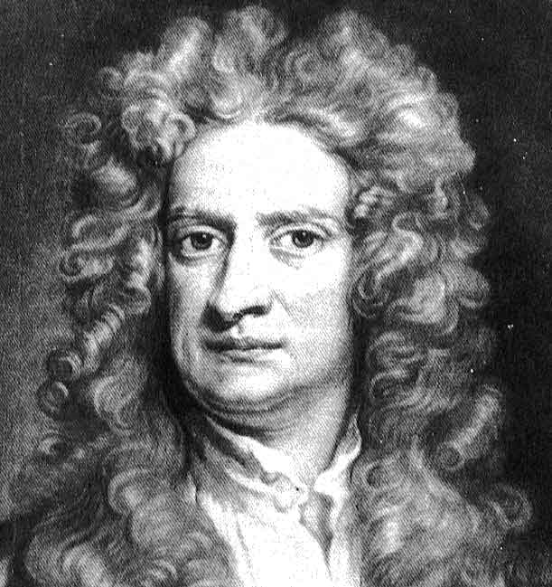 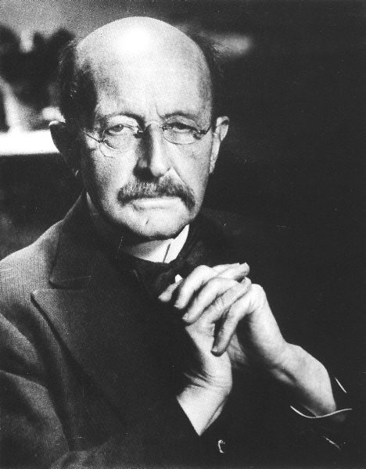 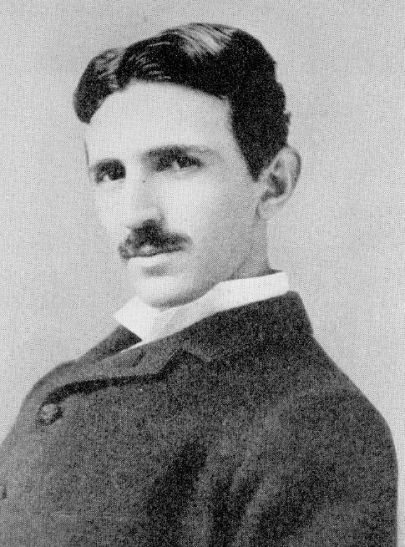 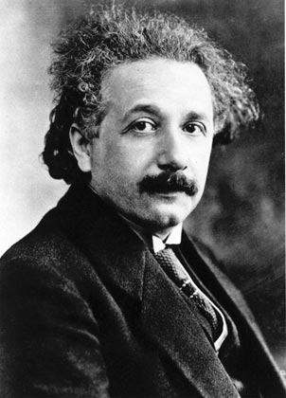

**What is required in your research report?**

**Title Page:**  research topic title, your name, date, teacher’s name.

**Table of Contents:** include the page numbers for the beginning of each section.

**Abstract (or Executive Summary):** thisis a paragraph, that if read by itself, summarises the topic researched in the least possible words (usually 100 – 150 words). It should include the principles/techniques employed and a very brief statement of your findings.

**(NOTE:** I accept table of contents and abstract on the one page, though in the scientific community this is not accepted – trying to save paper here peoples!)

**Introduction: (100 words).** Introduces the reader to the background and objectives. In the introduction you will need to do the following things:

* present relevant background or contextual material that is covered in rest of report (e.g. explain the focus of the paper and your specific purpose).
* define terms or concepts when necessary (e.g. full name at beginning of the paper only)
* be direct and precise – scientists don’t like to read a lot of hairy fairy additives and nor do I. Also you only have minimal space - 100 words.

**Body:** (300 words). It is important to group and sequence compiled material before writing.

* Use your outline and prospectus (i.e. table of contents and introduction) as guides to what should be in the body
* Build your report around points you want to make (i.e. don't let your sources organise your paper, that often leads to plagiarism)
* Integrate your sources into your discussion
* Summarize, analyse, explain, and evaluate published work rather than merely reporting it.
* **IMPORTANT: Minimum of 3 subjects within body and title each (which shows on your table of contents)**

**Conclusion: (100 words)**. The conclusion has to be very strong and leave the reader solidly understanding your report.

* Move from a detailed to a general level of consideration that returns the topic to the context provided by the introduction.
* Perhaps suggest what about this topic needs further research.
* Highlight the most poignant information including affects/disadvantages on society.

**Appendices:** Opportunity to include manuscripts, sketches and other interesting information. Just make sure they are referenced in the report.

**References:** See further on for detail.

Total of about 500 words or 1 page in Arial 12 font, excluding title page, table of content, appendices, citations, pictures and graphs.

**Important: Introduction, Body and Conclusion content to be presented 2x line spacing.**

**Referencing technique**

When writing a paragraph with referencing, there are two types: **Supporting your statement** and **Quoting**

***Example***

Australian rural and remote schools face many challenges when it comes to dealing with staff shortages. Motley, Rossi & King (2005), White (2006), Cavicchiolo & Davis (2006), McConaghy (2006), and Sharplin (2002) all agree that rural, and more specifically, remote schools have difficulty recruiting and retaining qualified staff.

Page (2006) talks further on the implications of these shortages in rural areas by noting the association of ‘quality learning outcomes for rural students (as) being related to preparing, attracting and retaining high quality teachers.’

Yet, this problem is not specific to Australia; New Zealand also suffers shortages in rural schools (Yates 2007), the United States rural schools are also experiencing shortages (Martinez 2004), as is England, where severe shortages in rural areas are an ongoing issue (Hudson & Hudson 2008).

* Unpopularity and perceived misconceptions of teaching in the rural settings (Sharplin 2002; Halsey 2006).
* Lack of Government incentives to assist teachers into locating to rural schools. There are some financial incentives, but these are either only on a temporary basis or not adequate enough to justify permanent relocation (Frid *et al.* 2008; Lane 2008; White 2006).

**Then in the reference section at the end of the report is the information of these cited remarks**

**Books or Journals**

Name of author(s), Date published, **'**Title of article**'**, *Publisher*, Volume, Pages sourced from, Web address **[**Date accessed by you**]**

***Examples***

Frid, S, Smith, M, Sparrow, L & Trinidad, S 2008, 'An exploration of issues in the attraction and retention of teachers to non-metropolitan schools in Western Australia.', *Education in Rural Australia*, vol. 18, no. 1, pp. 43-56.

Halsey, RJ, *Rural-Urban school partnerships and australia's sustainability*, Rural Education Forum Australia. Available from: <<http://www.acsso.org.au>> [26 September 2010].

**Speeches or Lectures**

***Example***

White, S, Lock, G, Hastings, W, Reid, J, Green, B & Cooper, M 2009, 'Supporting beginning rural teachers: Lessons from successful schools.', in *a paper presented at ‘Teacher education crossing borders: Cultures, contexts, communities and curriculum’ the annual conference of the Australian Teacher Education Association*, Australian Teacher Education Association, Albany pp. 1 - 15. Available from: <http://www.terranova.edu.au> [10th October 2010].

**News articles (both from news clippings and online)**

***Example***

# Strutt, J 2010a, *Crash Girls 'Get Tribal Punishment'*, 10th April 2010, The West Australian, Australia. Available from: <http://au.news.yahoo.com/thewest/> [10th April 2010].

# Strutt, J 2010b, '*Roebourne Plagued by Social Ills*', The West Australian, 16th March 2010.

**Research Topic Rubric for Year 11 Physics**

This report should be all about communicating ideas clearly and concisely. Remember you are not graded on the amount of forest cleared to make the paper used in your report.

|  |  |  |  |  |  |
| --- | --- | --- | --- | --- | --- |
| **Grade Topic** | **HD** | **D** | **C** | **P** | **N** |
| **Layout (Title Page, Table of Contents, Abstract, Appendices, References) and Overview**  **10%** | * Excellent professional standard for both layout and use of scientific language. * The sequence of the entire report and the sequence within each sub-heading is logical and suitable for the question being researched. * Each sub-heading is clear and correctly explained in relation to the investigation. * A mixture of high quality resources are included. | | * Good standard for both the layout and the use of scientific language. * The sequence of the entire report and the sequence within each sub-heading is evident and mostly relates to the question being researched. * Each sub-heading is clear and mostly explained in relation to the investigation. * A mixture of resources are included. | | * Virtually no standard for both the layout and the use of scientific language. * The sequence of the entire report and the sequence within each sub-heading is not clear and vaguely relates to the investigation. * Each sub-heading is listed, but poorly written. * A resource is included. |
| **Depth of Scientific knowledge**  **15%** | * Excellent use of scientific language which relates to the investigation. * Many references are used from a range of sources (e.g. texts, books, websites, DVD lab activities, journals etc.). * There is an in-depth understanding of the theoretical underpinnings of the topic in this report. | | * Good use of scientific language which relates to the investigation. * Some references are used from a limited range of sources. * There is an understanding of the theoretical underpinnings of the topic embedded in this report. | | * Poor use of scientific language which vaguely relates to the investigation. * No references are used. * There is no evidence of understanding the theory of the topic embedded in the report. |
| **Scientific Discovery/ Discussion**  **(Body of report)**  **30%** | * Excellent use of scientific language which relates to the investigation. * Many references are used from a range of sources (e.g. texts, books, websites, DVD lab activities, journals etc.). * There is an in-depth understanding of the theoretical underpinnings of the topic in this report. | | * Good use of scientific language which relates to the investigation. * Some references are used from a limited range of sources. * There is an understanding of the theoretical underpinnings of the topic embedded in this report. | | * Poor use of scientific language which vaguely relates to the investigation. * No references are used. * There is no evidence of understanding the theory of the topic embedded in the report. |
| **Affects/ Advantages/ Disadvantages**  **15%** | * Multi-layered understanding of the potential affects/advantages to society is embedded in the report. | | * Some understanding of the potential affects/advantages to society is embedded in the report. | | * Very little understanding of the potential affects/ advantages to society is embedded in the report. |
| **Referencing and Abstract**  **20%** | * Excellent use of scientific language which relates to the investigation. * Many references are used from a range of sources (e.g. texts, books, websites, DVD lab activities, journals etc.). * There is an in-depth understanding of the theoretical underpinnings of the topic in the abstract. | | * Good use of scientific language which relates to the investigation. * Some references are used from a limited range of sources. * There is an understanding of the theoretical underpinnings of the topic embedded in the abstract. | | * Poor use of scientific language which vaguely relates to the investigation. * No references are used. * There is no evidence of understanding the theory of the topic embedded in the abstract. |
| **Concluding Remarks**  **10%** | * The conclusion relates explicitly to the investigation into the topic researched. | | * The conclusion relates to the investigation into the topic researched. | | * The conclusion poorly relates to the investigation into the topic researched. |